

**TRIBHUVAN UNIVERSITY**

**INSTITUTE OF ENGINEERING**

**PASHCHIMANCHAL CAMPUS**

**A MIDTERM PROJECT REPORT**

**ON**

**HOME AUTOMATION SYSTEM**

**BY:**

|  |  |
| --- | --- |
| AMIT PATEL | PAS076BEL003 |
| AMRIT SUBEDI | PAS076BEL005 |
| DEEPAK ADHIKARI | PAS074BEL016 |
| SANJAY MANI POUDEL | PAS074BEL031 |
| SARBAJIT POUDEL | PAS076BEL034 |
| SHUSHANT DHAKAL | PAS076BEL045 |

DEPARTMENT OF ELECTRICAL ENGINEERING

POKHARA, NEPAL

January 23



**TRIBHUVAN UNIVERSITY**

**INSTITUTE OF ENGINEERING**

**PASHCHIMANCHAL CAMPUS**

**A MIDTERM PROJECT REPORT**

**ON**

**HOME AUTOMATION SYSTEM**

**PROJECT GROUP:**

|  |  |
| --- | --- |
| AMIT PATEL | PAS076BEL003 |
| AMRIT SUBEDI | PAS076BEL005 |
| DEEPAK ADHIKARI | PAS074BEL016 |
| SANJAY MANI POUDEL | PAS074BEL031 |
| SARBAJIT POUDEL | PAS076BEL034 |
| SHUSHANT DHAKAL | PAS076BEL045 |

**SUBMITTED TO:**

DEPARTMENT OF ELECTRICAL ENGINEERING

POKHARA, NEPAL

January 08,2023

ACKNOWLEDGEMENT

We have taken efforts in this project. However, it would not have been possible without the kind support. We would like to extend my sincere thanks to all of them.

We are highly indebted to Electrical Department for their guidance and constant supervision as well as for providing necessary information regarding the project & also for their support in completing the project.

We would like to express my gratitude towards the teacher of Electrical Department & our team members for their kind co-operation and encouragement which help us in completion of this project.

We would like to express my special gratitude and thanks to all persons for giving us such attention and time.

Our thanks and appreciations also go to our colleague in developing the project and people who have willingly helped us out with their abilities.

ABSTRACT

This project presents the overall design of Home Automation System (HAS) with low cost and wireless system. It specifically focuses on the development of an IOT based home automation system that is able to control various components via internet or be automatically programmed to operate from ambient conditions. In this project, we design the development of a firmware for smart control which can successfully be automated minimizing human interaction to preserve the integrity within whole electrical devices in the home.

We used Node MCU, a popular open source IOT platform, to execute the process of automation. Different components of the system will use different transmission mode that will be implemented to communicate the control of the devices by the user through Node MCU to the actual appliance. The main control system implements wireless technology to provide remote access from smart phone.

We are using a cloud server-based communication that would add to the practicality of the project by enabling unrestricted access of the appliances to the user irrespective of the distance factor. We provided a data transmission network to create a stronger automation.

Additionally, we are in progress to develop our own controlling app which helps in controlling all the home appliances connected to it. Mainly, we have focused in three aspects; control of home appliances, auto-door locking system and installation of camera focused to main gate for the protection from outsider activity in addition to in and out. All the things are done through single app.

The system intended to control electrical appliances and devices in house with relatively low-cost design, user-friendly interface and ease of installation. The status of the appliance would be available, along with the control on an android platform.

This system is designed to assist and provide support in order to fulfil the needs of elderly and disabled in home. Also, the smart home concept in the system improves the standard living at home.

TABLE OF CONTENTS

COVER PAGE…………………………………………………………………………..... i

TITLE PAGE……………………………………………………………………………….ii

ACKNOWLEDGEMENT………………………………………………………………….iii

ABSTARCT…………………………………………………………………………………iv

LIST OF TABLES………………………………………………………………………….vii

LIST OF FIGURES…………………………………………………………………………..vii

LIST OF ABBREVIATIONS……………………………………………………………….viii

CHAPTER ONE: INTRODUCTION…………………………………………………………1

1.1 BACKGROUND…………………………………………………………………………..1

1.2 PROBLEM STATEMENT………………………………………………………………..1

1.3 OBJECTIVE………………………………………………………………………………..2

1.4 SCOPE AND LIMITATIONS OF PROJECT……………………………………………...3

CHAPTER TWO: LITERATURE REVIEW…………………………………………………..4

2.1 BLUETOOTH BASED HAS………………………………………………………………..4

2.2 WIFI BASED HAS…………………………………………………………………………..4

2.3 HOME AUTOMATION USING ANDROID ADK………………………………………….5

2.4 RASPBERRY PIE HAS USING SMART PHONE…………………………………………..5

CHAPTER THREE: METHODOLOGY…………………………………………………………6

3.1 PROJECT LAYOUT………………………………………………………………………….6

3.2 NETWORK COMPONENTS………………………………………………………………...6

3.3 NETWORK MODULE………………………………………………………………………7

3.4 HARDWARE ASSEMBLY…………………………………………………………………..8

3.5 FLOWCHART……………………………………………………………………………….9

CHAPTER FOUR: RESULT AND DISCUSSION…………………………………………….10

CHAPTER FIVE: CONCLUSION AND RECOMMENDATION……………………………..11

REFERENCES…………………………………………………………………………………..12

LIST OF FIGURES

|  |  |  |
| --- | --- | --- |
| Figure  number | Figure | Page  number |
| 1. | Layout of project module | 6 |
| 2. | Node MCU | 7 |
| 3. | 4 channel relay board | 7 |
| 4. | Node MCU and 8 channel relay connection | 8 |
| 5. | Flowchart of prototype function | 9 |

LIST OF TABLES

|  |  |  |
| --- | --- | --- |
| Table number | Table | Page  number |
| 1. | Component listing | 9 |

LIST OF ABBREVIATION AND ACRONYMS

|  |  |  |
| --- | --- | --- |
| S.NO. | ACRYNOM | EXPANSION |
| 1. | IOT | Internet Of Things |
| 2. | Node MCU | Node Micro Controller Unit |
| 3. | Wi-Fi | Wireless Fidelity |
| 4. | HAS | Home Automation System |
| 5. | USB | Universal Serial Bus |
| 6. | PCB | Printed Circuit Board |

# CHAPTER ONE

# INTRODUCTION

* 1. Background

The concept of “Home Automation” has been in existence for several years. “Smart Home”, “Intelligent Home” are terms that followed and is been used to introduce the concept of networking appliance within the house. Home Automation Systems (HASs) includes centralized control and distance status monitoring of lighting, security system, and other appliances and systems within a house. HASs enables energy efficiency, improves the security systems, and certainly the comfort and ease of users. In the present emerging market, HASs is gaining popularity and has attracted the interests of many users. HASs comes with its own challenges. Mainly being, in the present day, end users especially elderly and disabled, even though hugely benefited, aren’t seen to accept the system due to the complexity and cost factors. But, an internet-based home automation system for remote control and observing the status of home appliances is designed. There are several connections among which WIFI is being chosen with its suitable capability. Also, most of the current laptop/notebook or Smartphone come with built-in WIFI adapter. It will indirectly reduce the cost of this system.

* 1. **Problem Statement**

The aim is to design a prototype that establishes wireless remote control over a network of home appliances. The application is designed to run on android device providing features like, switch mode control, voice command control and a provision to view the status of the devices on the application itself. Considering its wide range of application, following are the scope of this prototype. The system can be implemented in homes, small offices and malls as well, being in-charge of control of the electrical appliances. By the use of day-to-day gadgets, we can utilize them for a different perspective.

As with all computing devices, security will become a greater issue as more people use smart home devices. Smart home devices are usually linked to companion apps that can be used to control the devices. If hackers gain access to these apps, then it could have considerable security implications, as they will be able to control access to your home. The best way to mitigate against this is to ensure your smart home apps are as up-to-date as possible and that you install any software & security updates that become available for the apps.  in a few years, no one will question the fact that they control their lights with a voice command or clean their home with a robotic vacuum cleaner. Attack on smart home devices are not unheard of, but they are relatively rare. It is a personal choice to weigh up the security & financial risks against the range of benefits that smart home devices offer.

* 1. **Objective**
* To formulate the design of an interconnected network of home appliance to be integrated into the HAS. The objective to account for every appliance and its control to be automated and integrated into the network further formulated into the HAS.
* To develop the application that would include features of switch mode to control the applications.
* To be able to view the status of home appliances on the application, in order have a better HAS.
* To achieve flexibility in control of the home appliances, and device capable of Wi-Fi connectivity will be able to obtain a secure control on the HAS.

With a strong existing possibility of adding and integrating more features and appliances to the system, the designed system needs to be highly extensible in nature.

* 1. **Scope and limitations of project**

The proposed system has some scope and limitations:

* **Scopes**

Home automation is the wireless and remote control of different aspects of a living space like lighting, temperature, security, entertainment, etc. It performs with the help of connected smart devices and appliances that use communication technology like WiFi, Bluetooth and Ethernet, to share data and facilitate the efficient management of power consumption. It has advantages like:

**Cost-effective**: Home automation appliances have a longer life cycle than the regular device. Hence this saves money.

**Self-sufficient**: The home automation technologies come with the option of running on sustainable sources of energy like wind or solar power and even water harvesting.

**Eco-friendly**: The smart home appliances consume a minimum amount of power. This is because they use stored user data to modify the output. This means a fair amount of energy is saved.

* **Limitations**

1. Complex installation. Whether you decide to install a home automation device on your own or hire a professional to do so, the more complex a system is, the more time, money—or both—it can end up costing you.

2. Compatibility concerns. ...

3. Cost counts.

**CHAPTER TWO**

**LITERATURE REVIEW**

A home automation system means to grant the end users to manage and handle the electric appliances. If we look at different home automation systems over time, they have always tried to provide efficient, convenient, and safe ways for home inhabitants to access their homes. Regardless of the change in user’s hope, growing technology, or change of time, the appearance of a home automation system has remained the same.

**2.1 Bluetooth based HAS**

In Bluetooth based home automation system the home appliances are connected to the Arduino BT board at input output ports using relay. The program of Arduino BT board is based on high level interactive C language of microcontrollers; the connection is made via Bluetooth. The password protection is provided so only authorized user is allowed to access the appliances. The Bluetooth connection is established between Arduino BT board and phone for wireless communication. In this system the python script is used and it can install on any of the Symbian OS environment, it is portable. One circuit is designed and implemented for receiving the feedback from the phone, which indicate the status of the device.

**2.2 Wi-fi based HAS**

Wi-Fi based home automation system mainly consist three modules, the server, the hardware interface module, and the software package. Wi-Fi technology is used by server, and hardware Interface module to communicate with each other. The same technology uses to login to the server web-based application. The server is connected to the internet, so, remote users can access server web-based application through the internet using compatible web browser. Software of the latest home automation system is split to server application software, and Microcontroller (Arduino) firmware. The Arduino software, built using C language, using IDE comes with the microcontroller itself. Arduino software is culpable for gathering events from connected sensors, then applies action to actuators and pre-programed in the server. The server application software package for the proposed home automation system, is a web-based application built using asp.net. The server application software can be accessed from internal network or from internet if the server has real IP on the internet using any internet navigator supports asp.net technology. Server application software is culpable of, maintain the whole home automation system, setup, configuration.

**2.3 Home automation using Android ADK**

The devices of home are associate to the ADK and the Connection is established between the Android device and ADK. It has audio output that is from the Android device to the component and it also support for the component serves as one or more Human Interface Devices (HID) to the Android device. This paper depends upon Android and Arduino platform in which both are Free Open-Source Software. Including motion sensors for safety systems will detect an unauthorized action and it will automatically notice the user through cell phone or the security system.

**2.4 Raspberry pie HAS using smart phone**

Home Automation System has been developed with Raspberry Pi by reading the algorithm and subject of E-mail. Raspberry Pi guarantees to be an efficient platform for implementation powerful, and economic smart home automation. home automation using Raspberry pi is better than any other home automation methods in several ways. For example, DTMF (dual tone multi-frequency) using home automation, the call tariff is a big demerit, which is not the problem in their proposed method. In Home Automation using web server, the design of web server and the memory space required is dismiss by this method, because it just uses the already established web server service given by G-mail. LEDs were used to identify the switching action. This System is efficient and flexible interactive.

**CHAPTER THREE**

**METHODOLOGY**

**3.1 Project layout**

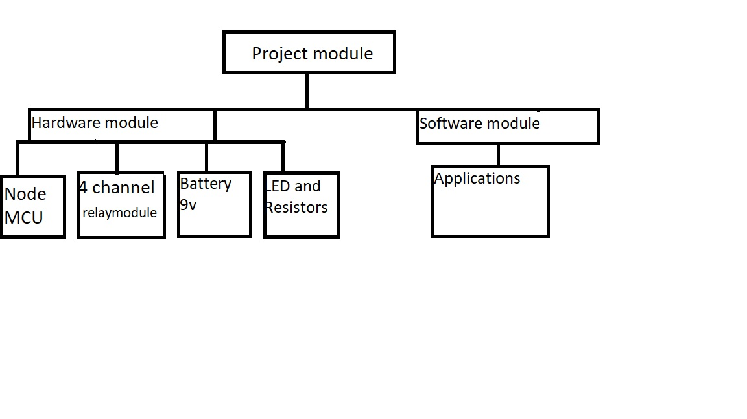

Figure 1: Layout of project module

Node MCU is the microcontroller unit in the prototype. It has an in-built Wi-Fi module (ESP8266) that establishes wireless remote switching of home appliances.

Channel relay module consists 8 individual relays physically connected between Node MCU and the home appliances. It takes signals form GPIO pins of Node MCU and accordingly connects or disconnects home appliances from the supply. They act as the switching device.

Bulbs, door, fan, camera etc are used in this prototype for real appliances. They indicate power being turned on and off to the appliances.

We design similar to the blynk Application. It can control hardware remotely, it can display sensor data, it can store data, visualize it, etc. the prototype primarily uses Blynk application to sense commands from user to the hardware over wireless network.

**3.2 Network Components**

Automation part is built by using following components: Node MCU is used for controlling the whole automation part of the smart home automation. It is connected with the other modules used in automation as shown in figure 3. It actuates different devices on the basis of sensors data. Sensors attached to Node MCU consists of: Temperature and humidity sensor, Motion Sensor, Electromagnetic door sensor, Gas Sensor, Electromagnetic Relays are used to control and automate the electrical appliances on the basis of sensed data. Energy monitoring part is used to monitor and control the energy consumption of home appliances especially heavy appliances by using web page and on an LCD, screen as shown in figure. This part consists of following modules: CC3000Wi-Fi module is attached to Arduino mega; which aims to provide data on the web page for further processing, actions and controlling.

**3.3 Network Module**

This section briefly discusses the network model of the proposed system. The proposed model is mainly based on two parts; Smart automation and Smart energy monitoring. These models are discussed in the rest of this section. The detailed prototype of proposed model is presented. Automation: - In this portion sensors are connected to the controller (Arduino Mega) and provides automation features of objects such as; Light is turned ON/OFF based on motion sensed by the sensor or any activity observed by the sensor. Furthermore, an alarm is generated when gas leakage is observed. Also, notifies when the main door is left open for at least 30 seconds. Energy monitoring: - In this portion temperature and current sensors are connected to the controller (Arduino Mega) temperature sensor is used to automate the fan in the room as the fan will automatically turn ON/OFF when the temperature rises to certain value and the fan speed will gradually increase with the increase in temperature. Current sensor is used to monitor the energy consumption of the appliances at home and a Wi-Fi module is used to send the data to the internet and is accessed on a web page. The values of energy consumption and temperature are shown on web page and the control of the appliance is also connected with the web page which can be accessed globally and cab be controlled.

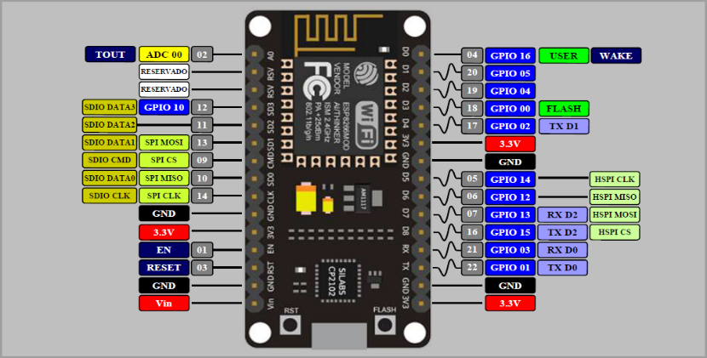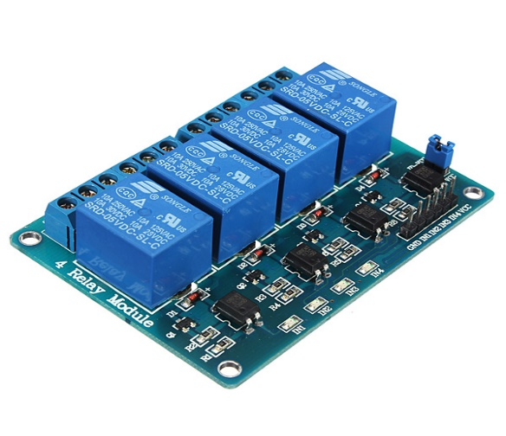

Figure 2: Node MCU Figure 3: Channel relay board

**3.4 Hardware assembly**

Hardware assembly mainly includes connecting specific digital pins of Node MCU to the 4 relays on the relay module, including the connection of supply and ground pins. The main functional assemble in this prototype is simple. The further 4 relays are fit to be connected to any appliance desired to be controlled. The vital part in hardware assembly is taking into account the digital pin that corresponds to which relay. This connection is done as per the setup of mobile application. The radio buttons on mobile application are set up to switch a particular digital pin in Node MCU. It is made sure that the relay connection is physically made according to this set up. For example, we have assigned the radio button on Blynk application corresponding to relay 1 to work with D3. Then physical connection of relay 1 is made with D3 of Node MCU.

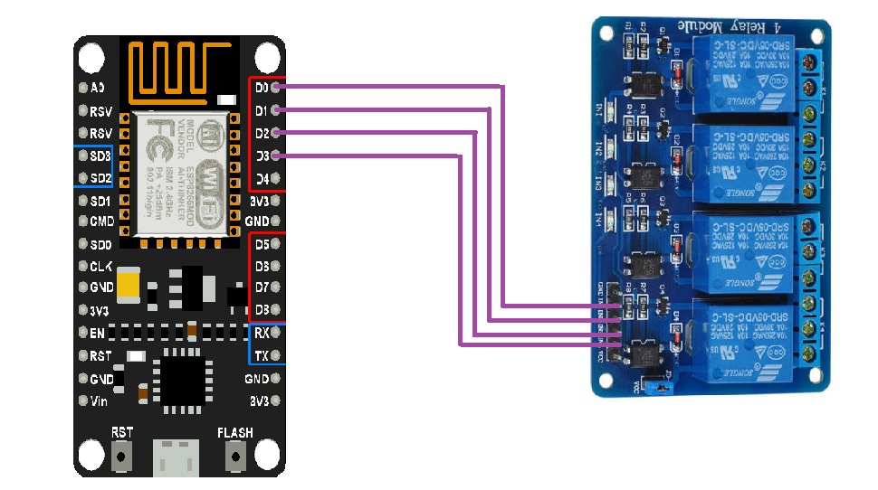

Figure 4: Node MCU and 4 channel relay connection

In this prototype instead of real home appliances, we connect the relays to LEDs, (according to circuit diagram) to just ensure the functionality of the prototype. The prototype is given a supply from a 9V battery.

**3.5 Flowchart**

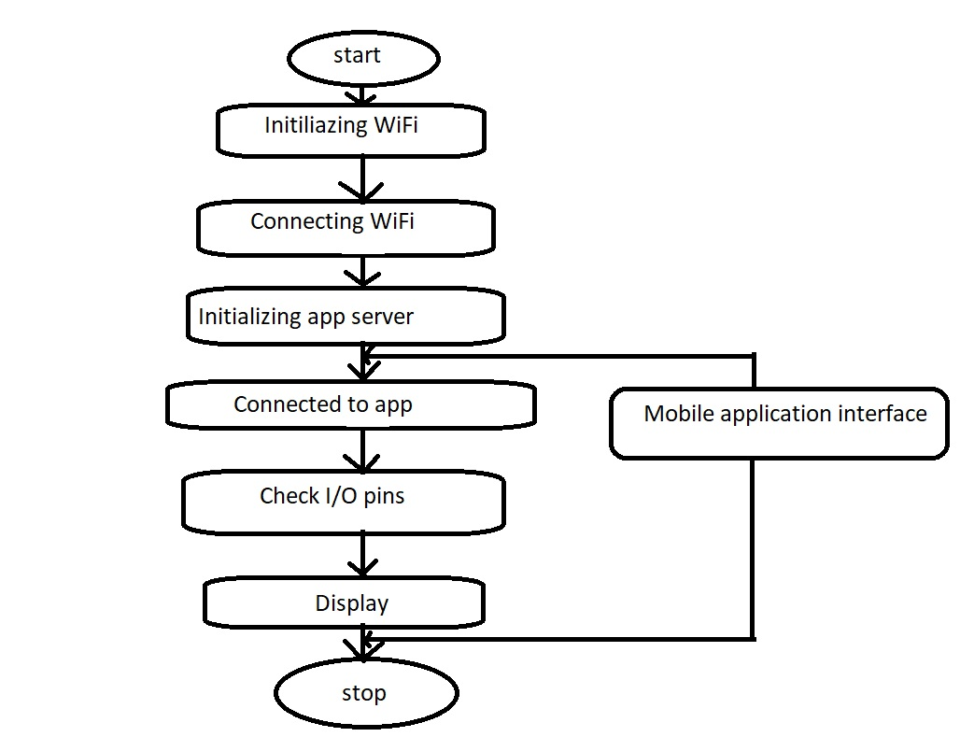

Figure 5: Flowchart of prototype function

This flow chart shows the working of the project. The process starts be initializing the Wi-Fi, the network name and password are written in the code and uploaded to Node MCU. The android device is connected to Node MCU over Wi-Fi. The app server is set up and connection is made, the devices is identified in the app server using the generated authentication token. The command for controlling the load is given to the application, and this command, over Wi-Fi network is sent to the Node MCU.

**CHAPTER FOUR**

**RESULT AND DISCUSSION**

It is evident from this project work that an individual control home automation system can be cheaply made from low-cost locally available components and can be used to control multifarious home appliances ranging from the security lamps, the television to the air conditioning system and even the entire house lighting system. And better still, the components required are so small and few that they can be packaged into a small inconspicuous container. The designed home automation system will be tested a number of times and certified to control different home appliances used in the lighting system, air conditioning system, home entertainment system and many more.

**CHAPTER 5**

**CONCLUSION AND RECOMMENDATION**

In this report, an IoT based algorithm is proposed for the smart home system to automate the Fan, bulb, monitor the house and notify by means of an alarm and energy monitoring. The proposed algorithm was practically implemented on Node MCU for the testing purpose. The result shows that, the algorithm is capable to observe the motion of a human being, to observe the intrusion by monitoring the line-of-sight communication between door and senor. The temperature and power consumption are monitored on a web page globally and can be monitored and controlled being away from home. Simulation results show that, the system is efficient and cost effective in terms of providing reliable information and automation. In future, this work can be to implement in a real-world home to automate it as smart home.

Survey of different home automation system shows that there are various kinds of technologies used to implement this type of system. All the proposed systems have been presented and compared in this paper which reveals some merits and demerits of the systems. This review explained different home automation system e.g. Web based, Bluetooth-based, mobile-based, SMS based, ZigBee-based, Arduino microcontroller based, Android app based, IOT based and cloud-based. Due to its performance, simplicity, low cost and reliability home automation system is making its position in global market, that day is not so far when every home will be the smart home.

**REFERENCES**

* [**https://www.Arduino.cc/en/Main/ArduinoBoardUno**](https://www.arduino.cc/en/Main/ArduinoBoardUno)
* [**http://www.instruconnect.net/Arduino**](http://www.instruconnect.net/Arduino)
* [**http://www.udemy.com/beginning-arduino**](http://www.udemy.com/beginning-arduino)
* [**http://www.learningaboutelectronics.com/Articles/Atmeaga328-pinout.ph**](http://www.learningaboutelectronics.com/Articles/Atmeaga328-pinout.ph)
* [**https://www.ijcttjournal.org/2017/Volume47/number-1/IJCTT-V47P109.pdf**](https://www.ijcttjournal.org/2017/Volume47/number-1/IJCTT-V47P109.pdf)